**VISVESVARAYA TECHNOLOGICAL UNIVERSITY**

**Jnana Sangama, Belgaum-590018**

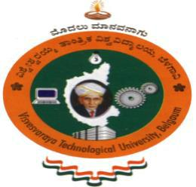

**A Database Management System Mini Project Report**

**on**

**“LIBRARY MANAGEMENT SYSTEM”**

**Submitted in Partial fulfillment of the Requirements for the V Semester of the Degree of**

**Bachelor of Engineering**

**In**

**Computer Science & Engineering**

**By**

**MB ASHISH**

**(1CR17CS066)**

**&**

**NEERAJ KUMAR**

**(1CR17CS080)**

**Under the Guidance of**

**Dr. Sugato Chakrabarty**

**Professor, Dept. of CSE**

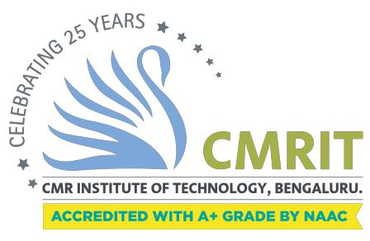

**DEPARTMENT OF COMPUTER SCIENCE AND ENGINEERING**

**CMR INSTITUTE OF TECHNOLOGY**

#132, AECS LAYOUT, IT PARK ROAD, KUNDALAHALLI,

BANGALORE-560037

**CMR INSTITUTE OF TECHNOLOGY**

#132, AECS LAYOUT, IT PARK ROAD, KUNDALAHALLI,

BANGALORE-560037

**DEPARTMENT OF COMPUTER SCIENCE AND ENGINEERING**



**CERTIFICATE**

This is to certify that the Database Management System Project work entitled **“LIBRARY MANAGEMENT SYSTEM”** has been carried out by

**M B Ashish (1CR17CS066) and Neeraj Kumar (1CR17CS080)** bonafide students of CMR Institute of Technology in partial fulfillment for the award of **Bachelor of Engineering** in **Computer Science and Engineering** of the Visvesvaraya Technological University, Belgaum during the year **2019-2020**. It is certified that all corrections/suggestions indicated for Internal Assessment have been incorporated in the Report deposited in the departmental library. This DBMS Project Report has been approved as it satisfies the academic requirements in respect of project work prescribed for the said degree.

**----------------------------------------------**

**Signature of Guide Signature of HOD**

**Dr. Sugato Chakrabarty Dr. Prem Kumar Ramesh**

**Professor Professor, Head**

**Dept. of CSE, CMRIT Dept. of CSE, CMRIT**

External Viva

Name of the examiners Signature with date

1.

2.